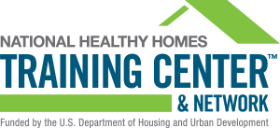
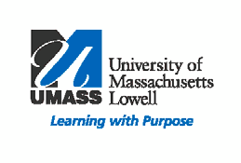
"Essentials for Healthy Homes Practitioners” Course

If you visit homes to provide health or inspection services of any type, you will benefit from the Essentials for Healthy Homes Practitioners Course. The training will help you understand the connection between health and housing and how to take a holistic approach to identify and resolve problems, which threaten the health and well--‐being of residents.

January 15 & 16, 2019
8:30am-4:30pm
Location:
UMass Lowell Health and
Social Science Building
Lowell, MA 01854

The training complements hazard-specific training in
lead-based paint, radon, mold, pests, and asbestos. It identifies root causes of health problems in a home and links them to seven principles of healthy housing: Keep it dry; Keep it clean; Keep it pest-free; Keep it ventilated; Keep it safe; Keep it contaminant-free; and maintain the house.
Course participants will have a better understanding of how to collaborate to make healthy homes a reality in their community. To learn more, please visit the National Healthy Homes Training Center and Network website: http://healthyhousingsolutions.com/hhtc/

Participants will learn how to:
− Identify key health issues related to housing.
− Reduce moisture, dust allergens, and contaminant sources within the home.
− Prevent common household injuries.
− Stay current with the latest research on healthy housing issues.

This course has been approved for Continuing Education Credit hours. To view the learning objectives go to: http://healthyhousingsolutions.com/wp-content/uploads/2014/12/Essentials_Learning_Objectives.pdf

CEUs Provided: Public Health Nurses (11.75), Social Workers (13.5), Registered Environmental Health Specialist/Registered Sanitarian &
Certified Environmental Health Technicians
(14.0), ASHI Home Inspector (2.0), NACHI Home Inspectors (15.0), Certified Industrial
Hygienist & Associate CIH (2.0), Indoor Air
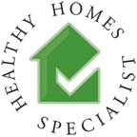
Quality Professional & Technicians (15.0), AACE Code Inspector (0.6), BPI Certified Professional (8).

The Essentials for Healthy Homes Practitioners course is presented by
UMass Lowell’s New England Healthy Homes Training Center and
National Healthy Homes Training Center
Who Should Attend:
- Environmental health professionals - Property managers
- Energy auditors - Public health nurses
- Health and housing advocates - Lead risk assessors
- Lead poisoning case managers - Pest control operators
- Housing inspectors - Weatherization specialists
- Licensed home inspectors - Community-based organization staff

Registration Information:
- Registration deadline: January 10, 2019
- Refreshments are included
- Program fee: $200 for government and non-profits; $230 for all others.
- Make checks payable to University of Massachusetts Lowell. Mail or email registration to:
David Turcotte
UMass Lowell New England Healthy Homes Training Center
Mahoney Hall Suite 212 E
870 Broadway Street Lowell MA, 01854
• For further information or to hold a space for you, as space is limited contact: David Turcotte at 978-934-4682 or David_Turcotte@uml.edu
Kelechi Adejumo at 978-934-5144 or Kelechi_Adejumo@uml.edu

Essentials for Healthy Homes Practitioners
January 15 & 16, 2019
Name(s)

Title

Organization

Address

City Lowell State Zip

Phone (day) Email

